Lab Report 2
ESE – 3005
EMBEDDED SYSTEMS ARCHITECTURE 2

Submitted to :
Linchan Wang
Submitted by:

Gurvinder Singh(748418)

Launch Qemu
a.) Initialize and build environment
- The command source oe-init-build-env is used to build the environment.
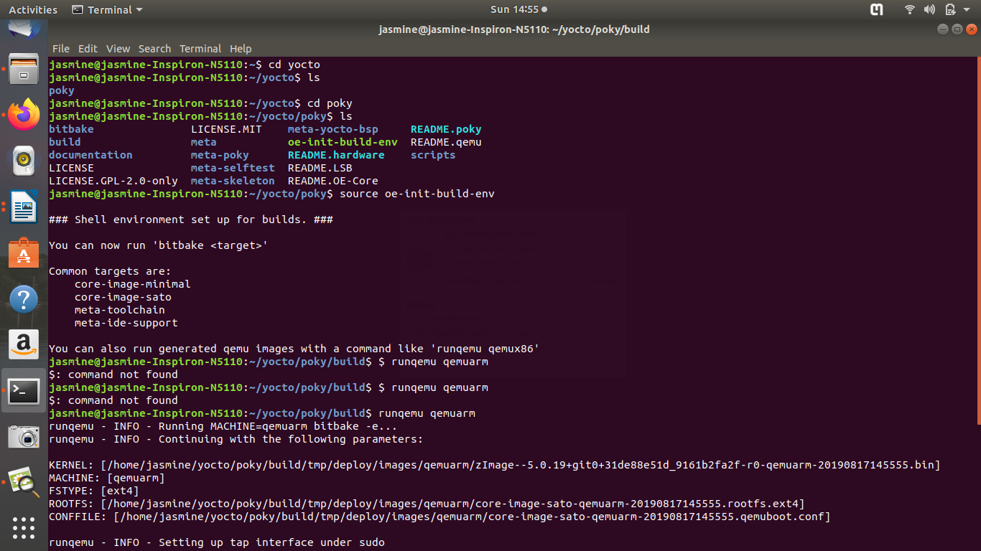

b.) Launch your Qemu
- In this game can be run and played by executing command “runqemu qemuarm”.
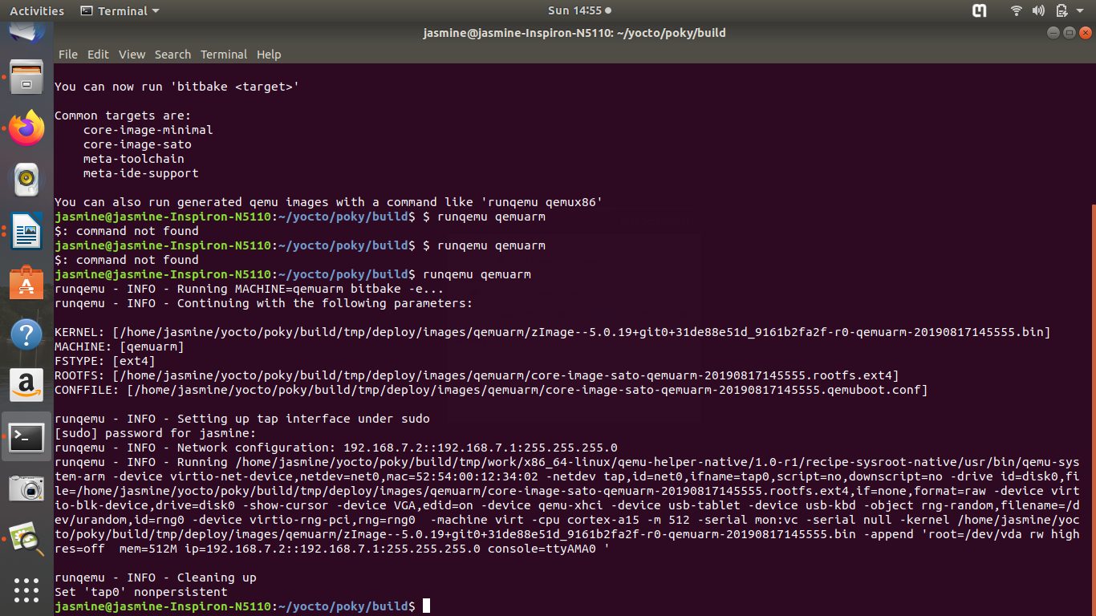
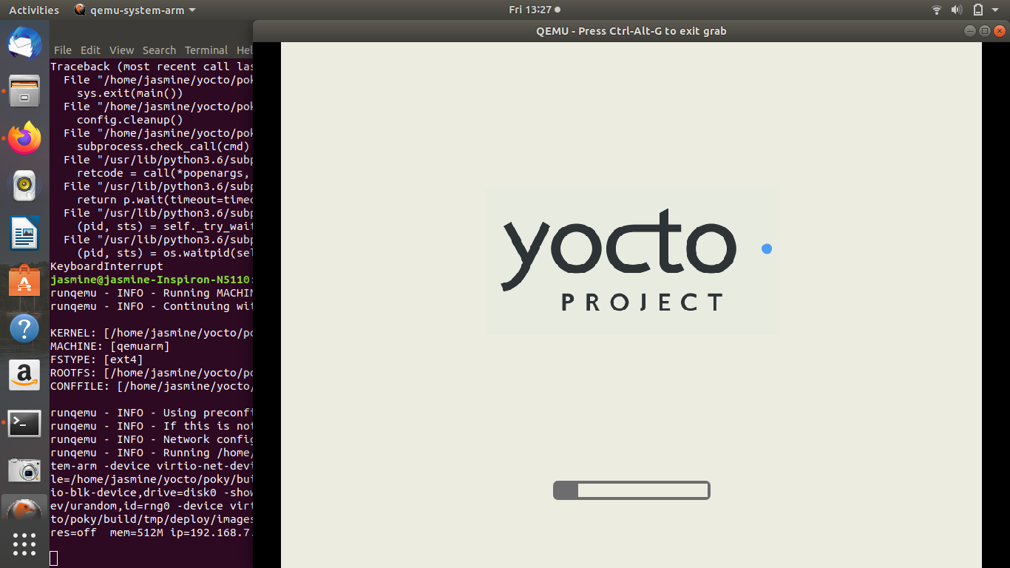
c.) Yocto Project is displayed which further helps to play the games.

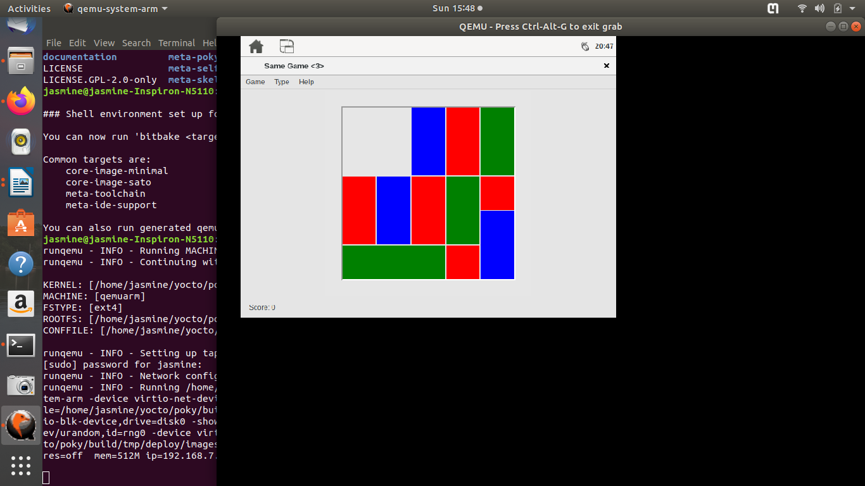
- In Applications , games option will appear , through which any of the games can be played.

